YouSee
Data Migration
Requirements Document

Version 0.5
Nov 4th, 2009

Sigma Proprietary and Confidential
Copyright Notice

Sigma Systems Copyright | The information contained within this document is proprietary and of significant commercial value to Sigma Systems. Accordingly, it may not be reproduced or disclosed by any means other than with the express written consent of Sigma Systems. The contents may not be disclosed except in confidence to Sigma employees or third parties for the purposes of this agreement and no other purpose.

Software Copyright | The software described herein is furnished under a license agreement, and it may be used or copied only in accordance with the terms of the agreement.

Document Copyright | No part of this document may be reproduced or transmitted in any form or by any means, electronic or mechanical, for any purpose, without the express written permission of Sigma Systems.  © 1996-2008, Sigma Systems Canada Inc., All Rights Reserved. Printed in Canada.

TABLE OF CONTENTS
Sigma Proprietary and Confidential 1
TABLE OF CONTENTS 2
1 Introduction 6
1.1 Objective 6
1.2 Purpose of this Document 6
1.3 Intended Audience 6
1.4 Instructions to Read this Document 6
2 Requirements Issues 8
3 Assumptions 8
4 Migration Overview 10
4.1 Scope 10
4.2 Approximate Subscriber Count for Data Migration 10
4.3 Migration Strategy 11
4.3.1 Pre-Migration Tasks 11
4.3.2 Cutover and Deployment 11
4.3.2.1 Outage Window(s) Details 11
4.3.2.2 Migration Process Diagram 12
4.3.3 External Data Extract Layout 13
4.3.3.1 Subscriber CSV 14
4.3.3.2 Cable Voice CSV 14
4.3.3.3 Cable Broadband 14
4.3.3.4 Mobile Broadband 14
4.3.3.5 Cable Video 15
4.3.3.6 PC Security CSV 15
4.3.4 Migration Process 15
4.3.4.1 Subscriber Data Migration 15
4.3.4.2 Service Migration 16
4.3.5 Error Handling Requirements 16
4.3.6 Rollback Requirements 17
4.3.7 Reporting 17
4.3.8 Migration Testing 17
5 YouSee Service Definition 18
5.1 High Level Service Definition 19
5.2 Subscriber Level Entities (SubStructure) 19
5.2.1 Subscriber Entity (SubSpec) 19
5.2.2 Subscriber Address Entity (SubAddressSpec) 19
5.2.3 Contact Parameters (SubContactSpec) 20
5.3 CPE Services Definition 20
5.3.1 Cable Modem/SMP HSD Access 21
5.3.2 PacketCable VoIP Access 22
5.3.3 SMP SIM Card 23
5.4 Cable Voice Services Definition 23
5.4.1.1 Dial Tone Access 24
5.4.1.2 Switch Feature 25
5.4.1.3 Voice Mail Service 25
5.5 Cable Broadband Services Definition 27
5.5.1 Internet Access 28
5.5.2 SMP Standard CPE 28
5.5.3 Additional CPE 29
5.5.4 SMP Static IP Service 29
5.5.5 SMP Email Server Unblock 30
5.5.6 SMP WiFi Service 30
5.6 PC Security Services 31
5.6.1 SMP PC Security 31
5.7 Mobile Broadband Services Definition 32
5.7.1 SMP Mobile Broadband Service Definition 33
5.7.2 SMP Mobile Broadband Service Attributes (smp_mobilebb_service_attribs) 33
5.8 Video Services 35
6 Consumable Resources migration 35
7 Topology migration 35
8 Product Decomposition 35
9 Documents 35
10 Error Scenarios 36

DOCUMENT CONTROL
Document Identifier | YouSee Subscriber Data Migration Requirements Document
The person responsible for keeping this document up-to-date is: | Sumit Borade
The person(s) who approves the use of this document is: | Miguel Ferreira
Document Status | Work In Process | Draft | Interim | Released
Version | 0.5

VERSION HISTORY
Version | Release Date | Author(s) | Notes
0.1 | November 4, 2009 | Sumit Borade | Initial Draft
0.2 | November 18, 2009 | Sumit Borade | Added the TDC subscriber id as required parm for mobile broadband. Updated for the additional CPE’ s (Max 5) and Added fsecure Key in PC Security.
0.3 | January 22, 2010 | Prashant Marathe | Updated the format of the CSV’s and added the static_ip_address in the cable broadband CSV.
0.4 | February 09, 2010 | Prashant Marathe | Updated for exact parameter names and data migration updated requirements from Yousee.
0.5 | March 24, 2010 | Prashant Marathe | Updated the CSV file structure for addition of the external key extracts from Yousee.

Document References
The following is a list of Sigma Systems and vendor-supplied publications that can be used as a reference while reading this document:

Title | File Name
YouSee Architecture Requirements Document
YouSee Business Requirements Document
Note: The current version of the above documents should be used. This document may not be updated with reference to current versions of the above mentioned documents.

Introduction

Objective
The objective of this document is to outline the data migration requirements of migrating YouSee subscriber’s information from the existing YouSee Provisioning system into SMP data base

Purpose of this Document
This document specifies the high level strategy, deployment approach and detailed data migration requirements as part of the overall Data migration for YouSee SMP Deployment Project

Intended Audience
The audiences of this document are:
- The YouSee project team responsible for the YouSee SMP deployment
- Sigma’s project teams that have to acquire a thorough understanding of the YouSee data migration Requirements

Instructions to Read this Document

Parameter Name | Is Required? | Validation Rule | Is Unique? | Notes/Comments
This column indicates name of the Parameter in SMP Service Definition | This Column indicates that parameters should be present in CSV. If Y indicates that this information must come for all the Subscribers from Triple | This Column will indicate the Validation Rules to be applied on the Data coming in the CSV for this particular parameter | This column indicates of this information should be unique in SMP. Uniqueness will be applicable for all the Services Instances across all the Subscribers | This column gives a brief description about the Information(Parameters)

For the Service Definition Diagram please follow below information to understand the Diagram:-

Service Relationship is represented using following convention:-
- Dotted Lines indicate Service Association
- Full Line indicate Service Dependency

Cardinality is specified in the Service Definition Diagram for Services:-

0:n : This means that subscriber can have minimum 0 to Maximum n Instances of the Services

1:1 : This means that Subscriber should have one Instance Service. He cannot have more or less than one.

1:n: This means that Subscriber should minimum one Instance Service and Maximum can be n.

0:1 :- This means that subscriber can have minimum o to maximum 1 instance of the Services

Requirements Issues
# | Brief Description | Detailed Description | Owner | Status
1 | Parameter Validation | Sigma and YouSee need to come up with the Parameter validations for the Information coming from the CSV Files | Sigma/Yousee | Open
2 | Open Orders | YouSee and Sigma need to come up with an approach for handling the Future Dated Orders in Stallone | Sigma/Yousee | Open
3 | Suspended Services | For suspended Services SMP should receive the Information in CSV files to indicate that the Service is currently suspended | Sigma/Yousee | Open

Assumptions
# | Brief Description | Detailed Description | Owner | Status
1 | YouSee Provisioning System | Once the CSV Files are created the Provsioning system at youSee should be down till the Data Migration Process is complete | YouSee | Closed
2 | Orders | Order(s) information will NOT be migrated. | YouSee | Closed
3 | Accurate Data | It is the responsibility of YouSee to provide the accurate information for each active subscriber. | YouSee | Closed
4 | No Migration to Network Elements | It is Sigma’s understanding that YouSee does not need Sigma to migrate the subscriber services into external platforms | YouSee | Closed
5 | Primary Key for Subscriber – Account Number | The account number will be used to uniquely identify the subscriber data. | YouSee | Closed
6 | Oracle 10g | The oracle database server version 10g is installed and configured in the production, staging and UAT environments as per the data migration requirements. | YouSee/Sigma | Closed
7 | Data Base Tuning | Any database tuning done for the purpose of running bulk migration jobs will be reverted back once the migration jobs are complete. Eg:- resumable parameter | YouSee/Sigma | Closed
8 | Unique Service Ids | YouSee will make sure that the Unique External Keys on Services are provided correctly to SMP | YouSee/Sigma | Closed
9 | Subscriber Address | It is Sigma’s assumption that if a subscriber will have only 1 address. | YouSee/Sigma | Closed
10 | Subscriber Information | The Subscriber Information present in all the Service data Extracts should be same | YouSee/Sigma | Closed
11 | Subscriber Account | If the Subscriber Account already exists in the SMP Data base then SMP will not update the Subscriber parameters but will proceed ahead with the Service Migration | YouSee/Sigma | Closed

Migration Overview

Scope
The data migration strategy is a traditional Database to Database migration. YouSee will dump all of the relevant data from the Existing System into some sort of standard media such as a CSV File. SMP will load these CSV files into the SMP database before the Go-Live date.

Data Migration will be done for following Services:-

- Cable Broadband
- Cable Voice
- Cable Video
- Mobile Broadband
- PC Security Service

Approximate Subscriber Count for Data Migration
- Cable Broadband :- 2,60,000
- Cable Voice:- 27,762
- Cable Video:- 1,50,000
- Mobile Broadband:- 1,818

Migration Strategy
The Data Migration for YouSee will be a Data Base to Data Base Migration. YouSee team will extract the Data from the Current Billing/Provisioning system and create the CSV files per Service as recommended by Sigma in the below Sections.

SMP Data Migration process will load the entire subscriber in the CSV files into SMP Data base.

The Data Migration Process will log the Erroneous subscribers and will proceed ahead with the Next Subscriber.

SMP Data Migration Process will give some Pre Validations script to validate the CSV files generated by YouSee team.

Pre-Migration Tasks
All the topology related data, Product Decomposition data and Inventory data base in SMP should be loaded prior to the Start of the Data Migration Process.

Pre-Migration assumes SMP 4.2 has been completely deployed and configured.

The following table lists Pre-migration tasks that may need to be performed.

Pre-Migration Tasks
Load the topology Data into SMP Data base
Retrieve Production dump and any complimentary extracts from Customer
(SMP, Non-SMP, Topology data)
Modify SMP tablespaces for SMP X.X
Configure DB server as per SMP requirements
Ensure all orders are closed/manual tasks cleaned up

Cutover and Deployment

The SMP Data Migration Process will migrate the Data for all the Existing subscribers from the Data Extracts (CSV Files) into SMP data base.

Outage Window(s) Details

The estimated tasks and run for this outage are as follows:

Migration Tasks
Step 1: DB Preparation
(export/import between servers, DB backup, Oracle upgrade, etc) (outside of outage window)
Step 2: Shutdown SMP 4.2
Step 3: Run extraction scripts for bulk of subscribers, approximately 50,000 entries per CSV file until complete.
Step 4: Produce the extracts in common location to be shared by extraction/’staging load process’. This will eliminate the need to ftp the extract files to the staging area
Step 5: Load the data-extracts (CSV files) in staging tables in SMP DB.
Step 6: Run SMP data transformation process.
Step 7: Repeat steps 3-6 as many times so the extracts can be processed concurrently as we are extracting the data.
Step 8: Start SMP
Post-Migration Tasks
Smoke Test
Validation and review of reports
Error cleanup
Rollback Tasks
Restore old DB etc
Total Hours

Migration Process Diagram
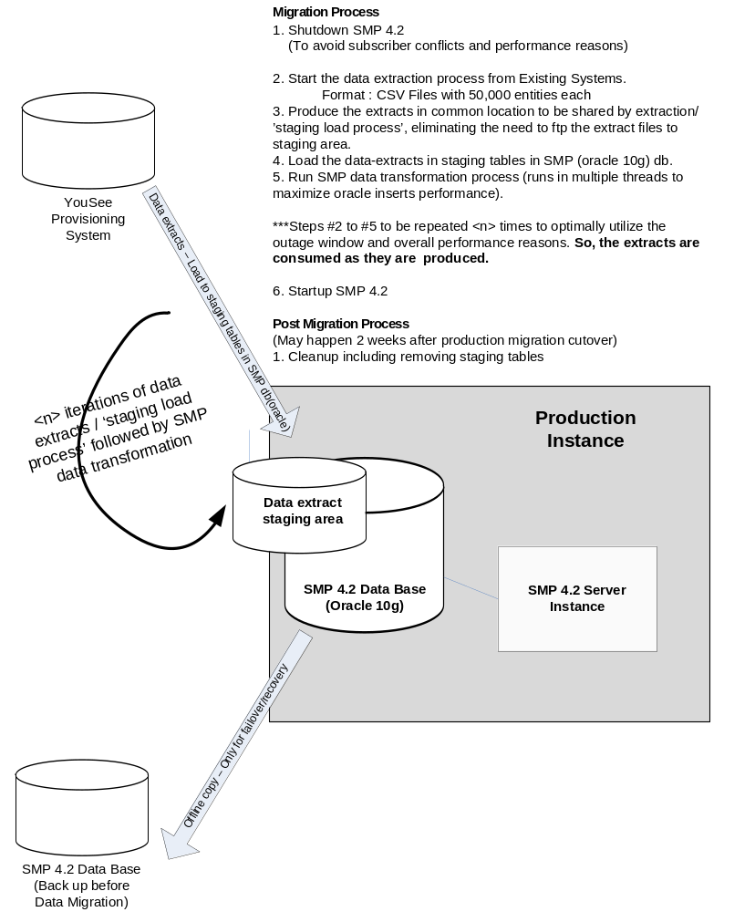

External Data Extract Layout

It is important to note that each parameter will be identified by its positional offset. If no data exists for that particular parameter, two pipes with no data will be there instead.

Number of Pipes is always constant for a CSV File.

Subscriber CSV
Subscriber.csv

Acct|first_name|middle_name|last_name|phones.home.number| phones.business.number|phones.business.extension|phones.cell.number|emails.home.address|ntd_return_segment_nm|city|country|zipcode|address1|address2|district|sub_status|

Cable Voice CSV
cableVoice.csv

Acct|sub_external_key|first_name|middle_name|last_name|phones.home.number| phones.business.number|phones.business.extension|phones.cell.number|emails.home.address|ntd_return_segment_nm|city|country|zipcode|address1|address2|district|sub_status|dialtone_service_id|smp_voice_line_external_key|telephone_number| mta_voice_port |rate_codes|Privacy|Cos_restrict_id|switchfeature_service_id| voicemail_service_id|Telephone_number| |cpe_compose_external_key|mta_service_id|mta_mac|mta_id| cm_service_id|equipment_type|cm_mac|wifi_capable| gi_address| docsis_3_capable| cm_ownership_id|voice_status|

Cable Broadband CSV
cableBroadband.csv

Acct| sub_external_key|first_name|middle_name|last_name|phones.home.number| phones.business.number|phones.business.extension|phones.cell.number|emails.home.address|ntd_return_segment_nm|city|country|zipcode|address1|address2|district|sub_status|cpe_compose_external_key|cm_service_id|equipment_type|cm_mac|wifi_capable| gi_address| docsis_3_capable| cm_ownership_id|cable_broadband_external_key|broadband_service_id|rate_codes| cpe_service_id | cpe_mac addl_ cpe_service_id |addl_ cpe_mac |addl_ cpe_product_code |addl_ cpe_service_id1 |addl_ cpe_mac1 |addl_ cpe_product_code1| addl_ cpe_service_id2 |addl_ cpe_mac2 |addl_ cpe_product_code2 | addl_ cpe_service_id3 |addl_ cpe_mac3|addl_ cpe_product_code3| addl_ cpe_service_id4 |addl_ cpe_mac4 |addl_ cpe_product_code4 |staticip_service_id| static_ip_address|staticip_product_code|email_server_unblock_service_id|email_server_unblock_product_code| wifi_service_id |wifi_service_product_code|ss_id|psk|gw_ch_id|cable_broadband_status|

Mobile Broadband CSV
mobileBroadband.csv

Acct| sub_external_key|first_name|middle_name|last_name|phones.home.number| phones.business.number|phones.business.extension|phones.cell.number|emails.home.address|ntd_return_segment_nm|city|country|zipcode|address1|address2|district|sub_status|
simcard_service_id|sim_card_id|mobile_broadband_external_key|mobilebb_service_id|mobilebb_product_code|mobilebb_msisdn|tdc_subscriber_id|suspension_type_id|mobilebb_service_attribs_id|mobile_broadband_status|

Cable Video CSV
cableVideo.csv

Acct| sub_external_key|first_name|middle_name|last_name|phones.home.number| phones.business.number|phones.business.extension|phones.cell.number|emails.home.address|ntd_return_segment_nm|city|country|zipcode|address1|address2|district|sub_status|cable_video_status|

PC Security CSV

pc_security.csv

Acct| sub_external_key|first_name|middle_name|last_name|phones.home.number| phones.business.number|phones.business.extension|phones.cell.number|emails.home.address|ntd_return_segment_nm|city|country|zipcode|address1|address2|district|sub_status| pcsecurity_service_id | pcsecurity_service_product_code | activation_date | email_to | fsecure_key|pc_security_status|

Note –

Following external keys will be generated by Yousee and will be included in the CSV extracts in the above formats.

- Sub_external_key for all subscribers.
- CPE_COMPOSE external key for Cable Broadband and Cable Voice
- Cable_Broadband external key for Cable Broadband
- Smp_external_key external key for cable Voice

Migration Process
The Sigma SMP data migration scripts will be a combination of Oracle PL/SQL and UNIX shell scripts.

Migration will occur on Cable Broadband, voice over cable, video over cable and mobile broadband services to bring the data into the SMP 4.2 database and enable management of these subscribers on SMP 4.2.

The Services will be created as per the Service Definition modeled for YouSee.

According to the YouSee requirements, Sigma will provide YouSee an opportunity to perform only Subscriber Data Migration first and then Perform Service Migration.

Or YouSee can choose directly to proceed ahead with the Service Migration which will have the Subscriber Data as well.

This will help YouSee to migrate with Service data migration without having any dependency on other services.

In either of the above cases subscriber data should be present in the Services csv files.

Subscriber Data Migration
When adding or updating the subscriber, it is important to check if the Account number exists in SMP 4.2. If the subscriber already exists, all that needs to be done is to add/update the services.

Sigma will not update the Subscriber, Subscriber address or Subscriber contact details if it already exists in SMP data base.

Subscriber will only have one address.

Service Migration
Service Migration will be done for following Services:-

- Cable Video
The CSV file for cable Video will have information about the Subscriber, Subscriber address, contact, smart Cards, Technical Packages and Video on Demand Service details.

The CSV will also contain information if the Cable Video Service is suspended. This will be contained in parameter cable_video_status. Valid values will be “SUSPENDED/ACTIVE”.

- Cable Voice
The CSV file for Cable Voice will have the information about the Subscriber, Subscriber address, Subscriber contact, Cable Modem, MTA and Cable Voice Plan.
Equipment for Cable Voice and Cable Broadband can be same. That is why information about the Cable Modem is also included in Cable Voice CSV.

The CSV will also contain information if the Cable Voice Service is suspended. This will be contained in parameter cable_voice_status. Valid values will be “SUSPENDED/ACTIVE”.

- Cable Broadband
The CSV file for Cable Broadband will have the information about the Subscriber, Subscriber address, contact, Cable Modem and Cable Voice Plan.

The CSV will also contain information if the Cable Broadband Service is suspended. This will be contained in parameter cable_broadband_status. Valid values will be “SUSPENDED/ACTIVE.

- Mobile Broadband
The CSV file for Mobile Broadband will have the information about the Subscriber, Subscriber address, contact, Sim Card and Mobile Broadband Plan.

The CSV will also contain information if the Cable Video Service is suspended. This will be contained in parameter mobile_broadband_status. Valid values will be “SUSPENDED/ACTIVE.

- PC Security
The CSV file for Mobile Broadband will have the information about the Subscriber, Subscriber address, contact and PC Security Service Information.

The CSV will also contain information if the Cable Video Service is suspended. This will be contained in parameter pc_security_status. Valid values will be “SUSPENDED/ACTIVE.

Each Service Migration will have the Subscriber Data.

SMP will first check if the Acct exists or not. If it exists SMP will add only the Services. If it does not exist then SMP will create the Subscriber and Services.

Error Handling Requirements
SMP standard Error Handling should be Specified.

SMP should propose all the best error handling methods for all the handled and unhandled Exceptions.

Refer to section 10.

Rollback Requirements
SMP standard Rollback Handling approach should be specified.

Rollback is only applicable for Services. Subscriber creation will not be Rollback.

Roll back in SMP should be done before any Order is fired in SMP.

For Example:-
If after Mobile Data Migration, Cable Broadband Data Migration was run and now if Mobile Data Migration needs to be rollback then only Mobile Services will be deleted from SMP Data base and not the Subscriber.

Reporting
SMP should provide some tools to YouSee to perform following operations:-

- View Data Migration Process Status
- View the Subscriber count of the Subscribers Migrated Successfully into SMP Data Base
- View the Service count of the Services Migrated Successfully into SMP Data Base.
- View the Subscribers with Erroneous Data.
- Error Information per Subscriber

Migration Testing
YouSee and SMP team should do a testing randomly on the Data Migrated subscriber to make sure the Data Migration process was successful.
.

YouSee Service Definition
The Service Definition models the Services offered by the Service Provider.

The Service Definition is created for modeling the Services offered by YouSee:-
- Broadband over Cable
- Voice over Cable
- Mobile Broadband
- Video over Cable
- PC Security Service

High Level Service Definition

Below is the High Level Service Definition Diagram which details out the Services a Subscriber has:-

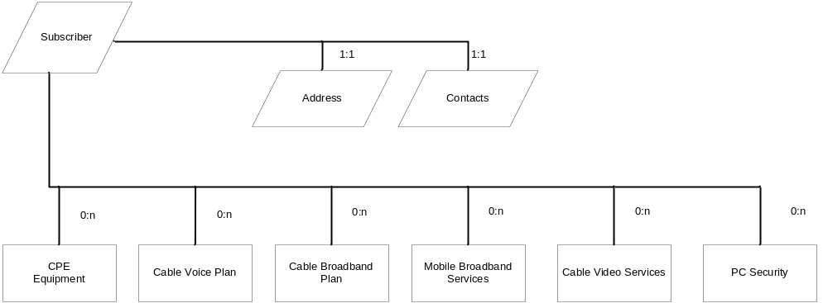

Subscriber Level Entities (SubStructure)

Subscriber Entity (SubSpec)
This Subscriber Entity in SMP will have all the information

Parameter Name | Is Required? | Validations | Is Unique? | Notes
Account (acct) | Y |  | Y | This is End User Account Number as currently Managed in Triple.

Subscriber Address Entity (SubAddressSpec)
SMP will maintain the Installation Address and not the Billing Address
Parameter Name | Is Required? | Validations | Is Unique? | Notes
Community Number (ntd_return_segment_nm) | Y |  | N | This is the Community Number.
City (city) | Y |  | N
Country (country) | Y |  | N
Zip Code (zipcode) | Y |  | N
Address1(address1) | Y |  | N
Address2(address2) | N |  | N
District(district) | Y |  | N

Contact Parameters (SubContactSpec)

Parameter Name | Is Required? | Validations | Is Unique? | Notes
First Name (first_name) | Y |  | N
Middle Name (middle_name) | N |  | N
Last Name (last_name) | Y |  | N
Phone Number (phones.home.number) | N |  | N
Business Phone Number  (phones.business.number) | N |  | N
Business Phone Number Extension  (phones.business.extension) | N |  | N
Cell Phone Number (phones.cell.number) | N |  | N
Email Home Address (emails.home.address) | N |  | N

CPE Services Definition

The CPE Services models the Customer premise equipment like Cable Modem,eMTA,Sim Card and Smart Card.
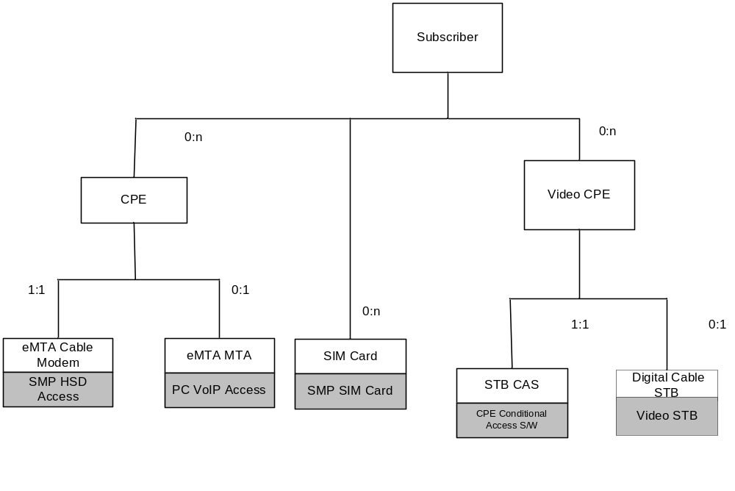

The above Service Definition models the Customer Premise Equipment (CPE) used to deliver the Service to the subscriber.

In YouSee a new composed service “CPE” has been defined. The CPE should always have a Cable Modem and an optional MTA.

Only Cable Modem Service will be created if it’s a standalone (Data only) Cable Modem.

MTA service will also be created under CPE composed Service if it’s an eMTA(Enhanced Multimedia Terminal Adapter).

Also, to support mobile broadband services a new equipment service “SIM Card” has been defined.

For Video Service, STB CAS (CPE Conditional access Service) has been created to model Smart Card.

Composed Service:- cpe_composed

Cable Modem/SMP HSD Access
This Service is used to Model the Cable Modem Information:-

Sub Type Service:- smp_emta_cm_hsd_access
Provisionable Service:- smp_hsd_access

Parameter Label (Parameter Name) | Is Required? | Validations | Is Unique? | Notes
CM Service ID (cm_service_id) | Y |  | Y | This is the Unique Identifier of the Cable Modem Service Created in SMP.
Equipment Type (equipment_type) | N |  | N | This identifies if it’s a Standalone Cable Modem(data only modem) or an eMTA
CM Mac (cm_mac) | Y |  | Y | This identifies the Cable Modem MAC address
CM WiFi Capable (wifi_capable) | N |  | N | This identifies if the Cable Modem is WIFI capable or not
GI Address(gi_address) | N |  | N | This is the GI address of CMTS
DOCSIS Capable (docsis_3_capable) | Y |  | N | This identifies if the Cable Modem is DOCSIS 3.0 capable or not.
CM Owner ship ID(cm_ownership_id) | Y |  | N | This is the Owner ID of the Cable Modem

Note: - As per the Yousee to support the newly added subscriber without the CM/CPE service active, Sigma will support the following condition internally in SMP data migration-
- cm_mac and cpe_mac both should either be null or both should have valid values.
- cm_mac or cpe_mac - if either of these are present then it should be marked as error record for manual correction by Yousee.

PacketCable VoIP Access
This Service is used to Model the Information about the MTA.

Sub Type Service:- smp_emta_pc_voip_access
Provisionable Service:- smp_pc_voip_access

Parameter Label (Parameter Name) | Is Reqed? | Validations | Is Unique? | Notes
MTA Service ID (mta_service_id) | Y |  | Y | This is the Unique Identifier of the MTA Service created in SMP.
MTA MAC (mta_mac) | Y |  | Y | This is the MAC address of the Cable Modem
Media Gateway ID(mta_id) | Y |  | Y | This is the Media Gateway Id to be used to provision an MTA on CISCO BTS

SMP SIM Card

SIM Card Service in Manages all the Information of a SIM Card.

Sub Type Service:- sim_card
Provisionable Service:- smp_sim_card

Parameter Label  (Parameter Name) | Is Required? | Validations | Is Unique? | Notes
SIM Card Service ID (simcard_service_id) | Y |  | Y | This is the Unique Identifier of the Service in SMP
SIM Card ID (sim_card_id) | Y |  | Y | This is the ICCID

Cable Voice Services Definition

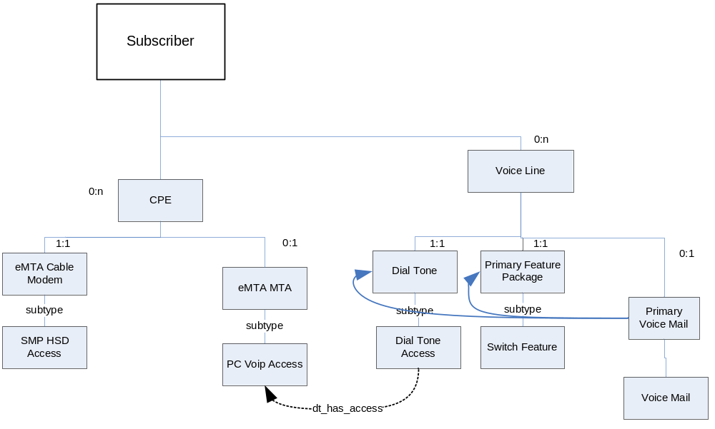

Diagram: YouSee Voice Network Services Definition Diagram

The Service Definition for Voice models the Cable Voice Plan as offered by YouSee.

Composed Service:- smp_voice_line

Dial Tone Access
The Voice line always contains a Dial Tone service which represents the local voice service with the ability to make and receive calls.The Dial Tone Access Service Models the Cable Voice Line(Telephone Number) of the subscriber.

Sub Type Service:- smp_switch_dial_tone_access
Provisionable Service:- smp_dial_tone_access

Parameter Label (Parameter Name) | Is Req’d? | Validations | Is Unique? | Comments
Dial Tone Service ID (dialtone_service_id) | Y |  | Y | This is the unique Identifier of the Service created in SMP
Telephone Number (telephone_number) | Y |  | Y | This is the Telephone Number of the subscriber
MTA Voice Port Number (mta_voice_port) | Y |  | N | The port number on the MTA to which this Voice line is associated
Product Rate Code  (rate_codes) | Y |  | N | In YouSee this parameter will map to Commercial Voice Product ID.
Privacy | Y |  | N | Valid values “FULL/NONE”
Cos_restrict_id | Y |  | N | Valid values 1-7 and “NULL”

Switch Feature
Feature Package Service will model the Fetaures on the Voice Line.

Sub type Service:- smp_switch_feature_pkg_std
Provisionable Service:- smp_switch_feature

Parameter Label (Parameter Name) | Is Req’d? | Validations | Is Unique? | Comments
Switch Feature Service ID (switchfeature_service_id) | Y |  | Y | This is the Unique Identifier of the Service in SMP

Voice Mail Service
Through the Data Migration all the Existing subscribers will have a Voice Mail associated with it.

Sub type Service:- primary_voicemail_box

Provisionable Service:- smp_voice_mail

Parameter Label (Parameter Name) | Is Req’d? | Validations | Is Unique? | Comments
Switch Feature Service ID (voicemail_service_id) | Y |  | Y | This is the Unique Identifier of the Service in SMP
Telephone_number | Y |  | N | This is the Telephone Number of the Cable Voice Plan

Cable Broadband Services Definition

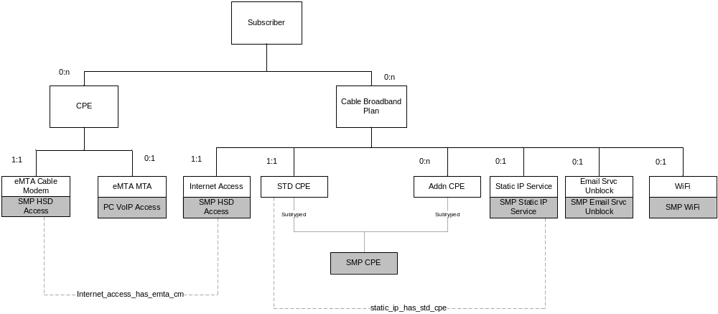

Diagram: YouSee Broadband Cable Plan - Service Definition Diagram

Internet Access:- This is the Service in SMP which will model the Cable Broadband Product.

STD CPE Service:- This Service will model the Computer or Gateway the subscribers uses for accessing Cable Broadband Plan.

ADDN CPE Service:- This Service will model the Additional Computers the subscriber can order behind the Cable Modem

Static IP Service:- This Service will model the Static IP instead of Dynamic IP for the Cable Broadband Plan.

Wifi:- This Service will managed the Wifi Security Service associated with the WIFI Capable Cable Modem

Email Srvc Unblock:- This Service will manage the Service to unblock Port Number 25 on Cable Modem for a subscriber so that he can host a Email Server behind the Cable Modem.

Composed Service:- cable_broadband

Internet Access

This is a definition Service in SMP for the Cable Broadband Plan.

Sub typed Service:- internet_access
Provisionable Service:- smp_internet_access

Parameter Label (Parameter Name) | Is Reqd? | Validations | Is Unique? | Comments
Broadband Service ID (broadband_service_id) | Y |  | Y | This is the Unique Identifier for the Service in SMP.
Product Rate Code (rate_codes) | Y |  | Y | In YouSee this parameter will map to Commercial Product ID.

SMP Standard CPE

This Service Models the Customer Premise Equipment(Computer) the Subscriber will use to access the Cable Broadband Service.

Sub typed Service :- std_cpe
Provisionable Service:- smp_std_cpe

Parameter Label  (Parameter Name) | Is Required? | Validations | Is Unique? | Comments
CPE Service ID  (cpe_service_id) | Y |  | Y | This is the Unique Identifier for the Service in SMP.
CPE MAC Address (cpe_mac) | Y |  | Y | This is the MAC address of the Cutomer Premise Equipement(Computer)

Additional CPE

The Additional CPE Service Models the addional Computers the subscriber can connect behind the Cable Modem

Sub typed Service:- additional_cpe
Provisionable Service:- smp_std_cpe

Parameter Label  (Parameter Name) | Is Required? | Validations | Is Unique? | Comments
Additional CPE Service ID  (cpe_service_id) | Y |  | Y | This is the Unique Identifier for the Service in SMP.
Additional CPE MAC Address (cpe_mac) | Y |  | Y | This is the MAC address of the Customer Premise Equipment(Computer)
Additional CPE Product Code (cpe_product_code) | Y |  | N | Commercial Product Code of the additional CPE as offered in Triple

SMP Static IP Service
This service is used to maintain the Static IP assigned to a Subscriber’s Standard CPE. This Service will not be offered to the Additional Computers connected behind the Cable Modem.

Sub typed Service:- static_ip_cpe
Provisionable Service:- smp_static_ip

Parameter Label  (Parameter Name) | Is Required? | Validations | Is Unique? | Comments
Static IP Service ID  (staticip_service_id) | Y |  | Y | This is the Unique Identifier for the Service in SMP.
Static IP address (static_ip_address) | Y |  | Y | This is the static ip address allocated to the subscriber.
Static IP Product Code (staticip_product_code) | Y |  | N | This is the Commercial Product Code of the Static IP Service as offered in Triple

SMP Email Server Unblock

This Services manages the Product for a Subscriber to enable hosting Email Server behind the Cable Modem.

Sub typed Service:- email_server_unblock
Provisionable Service:- smp_email_server_unblock

Parameter Label  (Parameter Name) | Is Required? | Validations | Is Unique? | Comments
Email Server Unblock Service ID  (email_server_unblock_service_id) | Y |  | Y | This is the Unique Identifier for the Service in SMP.
Email Server Unblock Product Code (email_server_unblock_product_code) | Y |  | N | This is the Commercial Product Code of Hosting an Email Server behind the Cable Modem

SMP WiFi Service

Sub typed Service:- wifi_service
Provisionable Service:- smp_wifi_service

This Service Manages the WIFI Security Product for WIFI capable Cable Modems.

Parameter Label  (Parameter Name) | Is Required? | Validations | Is Unique? | Comments
WiFi Service ID  (wifi_service_id) | Y |  | Y | This is the Unique Identifier for the Service in SMP.
WiFi Service Product Code (wifi_service_product_code) | Y |  | N | This is the Commercial Product Code of WIFI Service Product for WIFI capable cable Modems
SSID (ss_id) | Y |  |  | This is part cm properties at BACC.
PSK (psk) | Y |  |  | This is part cm properties at BACC.
GW Channel ID (gw_ch_id) | Y |  |  | This is part cm properties at BACC.

PC Security Services
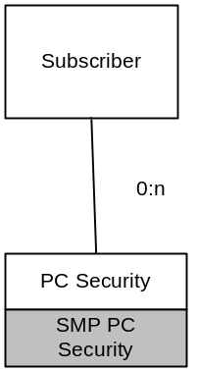

YouSee Subscriber can have PC Security Package with Cable Broadband or Mobile Broadband Package.

PC Security Service for Antivirus is independent on the Broadband Access technology.

PC Security Service is directly modeled under Subscriber so that it can be used for either Cable Broadband or Mobile Broadband.

No composed Service is required for PC Security Service.

SMP PC Security

The PC Security Service Models the Antivirus Service for a Subscriber.

Sub typed Service:- pc_security
Provisionable Service:- smp_pc_security

Parameter Label  (Parameter Name) | Is Required? | Validations | Is Unique? | Comments
PC Security Service ID  (pcsecurity_service_id) | Y |  | Y | This is the Unique Identifier for the Service in SMP.
PC Security Service Product Code (pcsecurity_service_product_code) | Y |  | N | This is the Commercial product code offered by YouSee for PC Security Services
Activation Date (activation_date) | Y |  | N | This is the Activation Date on FSecure Keys on Fsecure System
Email To(email_to) | Y |  | N | This is the Email address of the Subscriber to which the FSecure Key has to be Sent

Mobile Broadband Services Definition

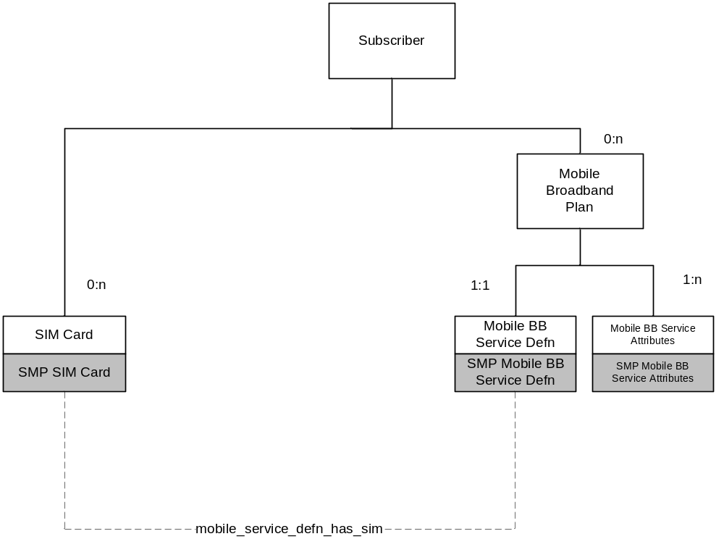

Diagram: YouSee Mobile Broadband Service Definition

Mobile Broadband Services are modeled with a Mobile Broadband Definition Service containing the information of the Mobile Broadband Commercial Product Code and MSISDN.

Mobile Broadband Service Attributes will model the Service Features Associated with the Mobile Broadband Plan.

Composed Service:- mobile_broadband

SMP Mobile Broadband Service Definition

Mobile Broadband Services are modeled with a Mobile Broadband Definition Service containing the information of the Mobile Broadband Commercial Product Code and MSISDN.

Sub Type Service:- mobilebb_service_def
Provisionable Service:- smp_mobilebb_service_def

Parameter Label  (Parameter Name) | Is Required? | Validations | Is Unique? | Comments
Mobile Broadband Service ID  (mobilebb_service_id) | Y |  | Y | This is the Unique Identifier for the Service in SMP.
Mobile Broadband Product Code (mobilebb_product_code) | Y |  | N | This is the Commercial Product for the Mobile Broadband
Mobile Broadband MSISDN (mobilebb_msisdn) | Y |  | N | This is the Telephone Number for the Mobile Broadband Service
TDC Subscriber ID | Y |  | N | This is the TDC subscriber id.
suspension_type_id | N |  | N | This is the Suspension Type ID that has to be send to TDC for Suspending a Mobile Broadband Service

SMP Mobile Broadband Service Attributes (smp_mobilebb_service_attribs)

Mobile Broadband Service Attributes will model the Service Features associated with the Mobile Broadband Product. Triple will create this Service.

Based on the Commercial Mobile Broadband Product and following the Product Decomposition Rules SMP will populate the Commercial Product Service Features.

Sub Type Service:- mobilebb_service_attribs
Provisionable Service:- smp_mobilebb_service_attribs

Parameter Label  (Parameter Name) | Is Required? | Validations | Is Unique? | Comments
Mobile Broadband Service attributes ID  (mobilebb_service_attribs_id) | Y | Triple | Y | This is the Unique Identifier for the Service in SMP.

Video Services

To be Discussed

Consumable Resources migration
Before the Data Migration process SMP Inventory Data base should be loaded with the FSecure Keys and Smart Cards for all the Existing subscribers with “Assigned” State

SMP will perform this pre validation before the Cable Video Data Migration Process and PC Security Data Migration process begins.

Topology migration
Before the Data Migration Process SMP topology data base should be loaded with all the information for
- CMTS
- Community Number

SMP Data Migration process will perform this pre validation before the Cable Broadband and Cable Voice Data Migration Process begins.

Product Decomposition
Before the Data Migration Process SMP Product Decomposition data base should be loaded with all the information for:-

- Cable Broadband Products
- Mobile Broadband Products
- Cable Voice Products
- Cable Video Technical Packages

All the Product Codes for all the above products should be present in SMP Product Decomposition Data base.

SMP Data Migration process will perform this pre validation before the Data Migration Process begins.

Documents
YouSee has requested following documents from Sigma for Data Migration

- Data Migration Design Document
- Data Migration steps Document
- Oracle 10 g configuration and Sigma Recommendations

Error Scenarios
When running the subscriber migration script, the errors encountered will be captured. There are two kinds of errors: SMP specific errors and Generic errors.

The SMP specific errors are captured in the ERR_TABLE table with the corresponding Account Number (ACCT), error number (ERR_NUM), error message (ERR_MSG) and error date (ERR_DT). The table below shows the possible error numbers, error messages and the corresponding error interpretation.

ERR_NUM | ERR_MSG | Interpretation
1 | MANDATORY FIELD NOT PRESENT | This error will be returned if any mandatory field is missing in the CSV File
2 | CMTS NOT FOUND | This is no data Found Error.  CMTS not found in SMP topology data base
2 | COMMUNITY NUMBER NOT FOUND | This is no data Found Error.  CMTS not found in SMP topology data base
2 | FSECURE KEY NOT FOUND IN SMP INVENTORY DATA BASE | This is no data Found Error.  FSecure Key not found in SMP Inventory data base
2 | SMART CARD NOT FOUND IN SMP INVENTORY DATA BASE | This is no data Found Error.  Smart Card not found in SMP Inventory data base
2 | NO PRODUCT FOUND FOR THIS PRODUCT CODE IN SMP PRODUCT DECOMPOSITION DATA BASE | This is no data Found Error.  Product Code not found in SMP Product Decomposition data base
3 | DUPLICATE RECORDS | This error will be returned if the CSV file contains duplicate records
Any Oracle ERR NUM | Any Error starting with ORA- is an oracle error. | SUB Migration Failed for this Account.

